Title in Helvetica (9 pt Bold) Using First Capital Letters (Recommended Size: Two Lines) |  |  |  | ORAL/POSTER
 |  |  |  | Ph.D. Student: Y/N
 |  |  |  | Journal: NONE
X. Surname¹, Y. Surname², Z. Surname^{1,2}. (1) Institution, Address, City, Country, email of the 1st author. (2) Institution, Address, City, Country

“Graphical Abstract”  - Figure, scheme, etc.  - The size should not exceed the size of this area  - Must be legible in “black & white” or “colour” formats |  | This section should provide a short abstract that should include the novelty and main findings of the work (Helvetica 8.0 pt, left-justified). It is imperative that the size of this section must not exceed the size of the text box (16 lines). Abstracts will be considered only if the following guidelines are respected. The list of the authors, institution and address must be typed in Helvetica 7.5 pt italic. The first author must be the researcher that will present the communication (poster, short-oral, oral or plenary) at the conference (bold) and must be registered for the CIPOA conference. This section will be included in a book of “Graphical Abstracts”.

Introduction
It is important to strictly follow the format of this document. Please do not modify the margins and follow the guidelines. We strongly recommend typing the abstract over this template in order to ensure that all abstract contributions have the same style. Abstracts should be submitted electronically in MSWord format. The file should be named as “Name.Surname_x.doc”, corresponding to the presenting author (ex: Cipoa.Floripa_1.doc) and the number corresponds to the number of submitted works by the same first author.
Each registration allows the submission of 2 abstracts. For the submission of further works (more than 2 abstracts), the author must contact the organizing committee and an additional XXX€ will be charged for each extra work.
The official language of the meeting is English. Therefore, the abstract must be written in English and must include the “Graphical Abstract” as presented in the template, and cannot be longer than 2 pages for oral, short-oral and poster presentations. Invited speakers must also submit an abstract about the research to be presented in CIPOA meeting.

Material and Methods
The work must include an introduction (objectives at the end of the introduction section), material and methods, results and discussion, and conclusions sections. Only will be accepted works that include results and conclusions, which means that preliminary results will not be accepted.

Results and Discussion
Leave one line (8 pt) before and after each figure. Please submit figures with good resolution. Please be aware that the “Graphical Illustration” can be also referred within the text and must not be repeated in this section (as shown in the Graphical Illustration).
Try to use as best as possible the space for the Figures, for example, including side by side, as (a) and (b). The Figures and the respective captions must be included inside of a table.
Registered participants presenting their work at CIPOA will have the possibility to publish full papers in a special issue of “XXX” (Publisher; Impact Factor = XXX). The interest should be mentioned above, in the red box, by replacing “NONE” by “XXX”. Please also indicate the preference for your presentation (ORAL, SHORT-ORAL or POSTER).
Only Ph.D. students will be selected for SHORT-ORAL communications. Ph.D. students must select Y in the red box. The remaining participants must select N in the red box.
The international scientific committee will make a preliminary selection of the works submitted to the VI CIPOA, considering scientific quality standards required to be submitted to the respective special issue.
The articles will be submitted to regular peer reviewing upon submission. The manuscripts need to be of relevant scientific novelty and the scientific content needs to be of high quality. The guidelines for the manuscript preparation must be in agreement with the journal instructions (please consult the journals website; www.cipoa.org).
Authors of the selected abstracts will receive an invitation letter no later than day/month/year in the email given as the corresponding author address. Each author should reply to the email specifying the type of article (critical review or research paper), containing its preliminary title and the name of the authors. The invitation letter must be attached during the submission process as a "Supplementary Material" file.
Authors contributors to the special issue must imperatively select "SI:XX" as an article type when they submit their manuscript (as the first step of submission procedures) through the Editorial Manager system (website). As for the deadline, we expect to receive all "SI:XX" contributions by day Month of year.
The special issue will feature both critical reviews and research papers. A review is expected to present a critical overview of the state-of-the-art of a topic, with critically selected examples (not only from your own work), to point the reader to trends and likely future developments and to give a selection of important references to the current literature.
Additionally, the works presented at CIPOA meeting will be published as: Book of “Graphical Abstracts” and “Books of Proceedings”.
Tables must follow the format below. Leave one line before and after each table (8 pt).
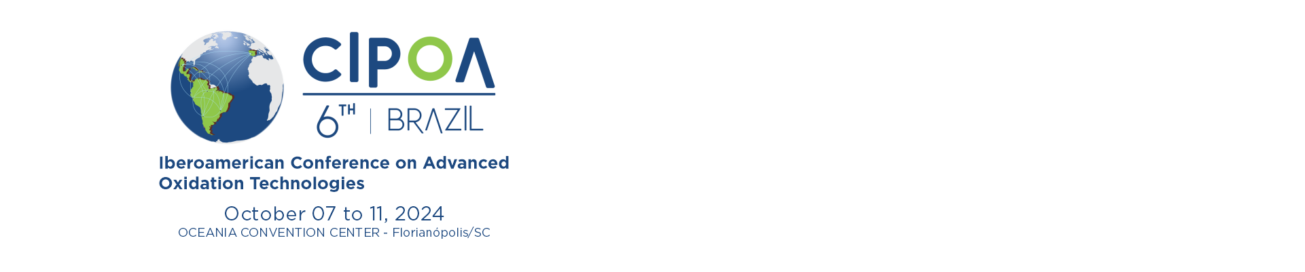

Figure 1. Caption (Helvetica 7 pt).

Table 1. Title (Helvetica 7 pt).ª
Helvetica | 7pt | Bold
Helvetica | 7pt
Helvetica | 7pt
Helvetica | 7pt
ª Footnote text if needed (7 pt).

Conclusions
References should be sequentially numbered in the text and cited as [1], [2] or [1,2]. Please follow the corresponding styles for articles in journals [1], conference proceedings [2], books [3] and articles in books [4]; a maximum of 10 references is recommended.

Acknowledgments
Feel free to contact the organizing comittee for any further information.

References
[1] X. Author, Y. Author, Z. Author, Journal name, volume (year) first page.
[2] X. Author, Y. Author, Z. Author, Proc. of XXXXXXX, City, Country, year, first page.
[3] Title of the Book, X. Editor, Y. Editor, Z. Editor (Eds.), City, Publisher, year.
[4] X. Author, Y. Author, Z. Author, in Title of the book section, X. Editor, Y. Editor, Z. Editor (Eds.), City, Publisher, year, first page.

