**Vaporizer Panel Cooler Installation Instructions**

*Figure 1. Overall mechanical component layout*

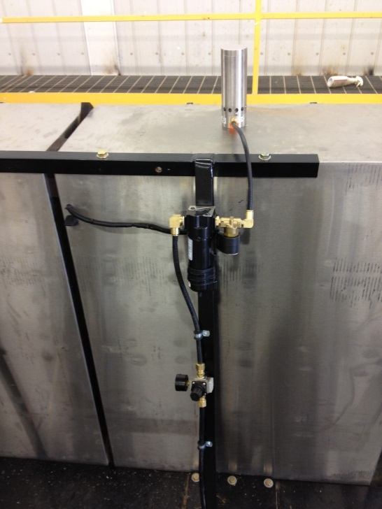

Using hole saw, mount cabinet cooler module to top of the VFD box. Drill hole so that the exhaust muffler is situated directly between the VFDs and directly behind the Plexiglas shielding.

*Figure 2. Exhaust Module positioning inside box*

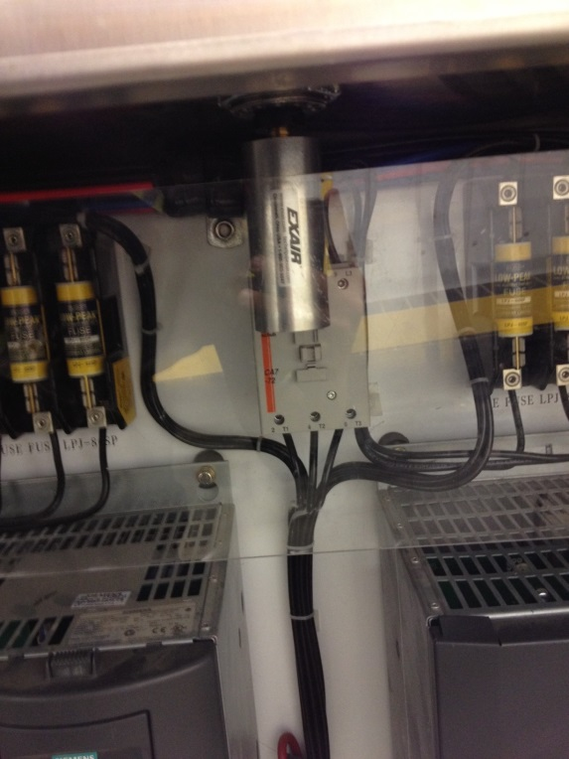

Using provided hardware, attach solenoid valve to the discharge side of water separator. Then mount to support bracket on the back of the VFD panel. Use supplied quick connect fittings to install synflex air line from solenoid to cooler module.

*Figure 3. Water separator and solenoid valve*

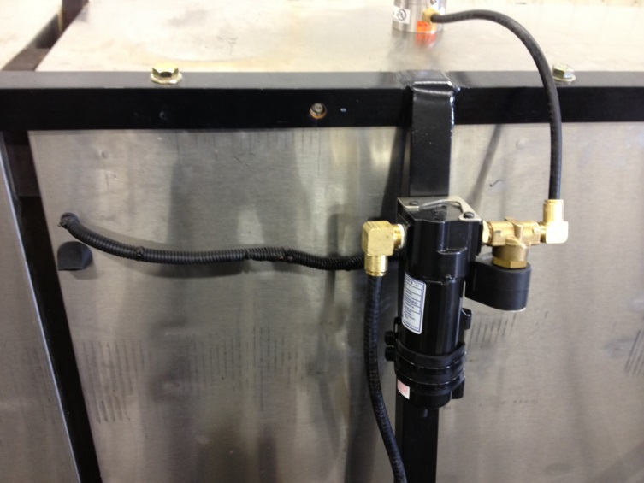

Use air supply from trailer by T-ing into red trailer airline inside of frame rail. Drill hole and rout airline directly up to the box support arm where water separator is mounted.

*Figure 4. Air supply from trailer*

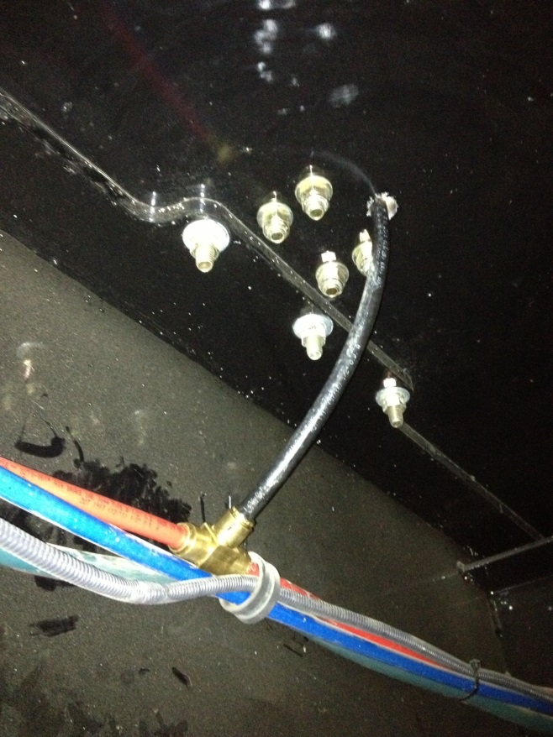

Install pressure regulator and gauge in line before water separator.

*Figure 5. Pressure Regulator*

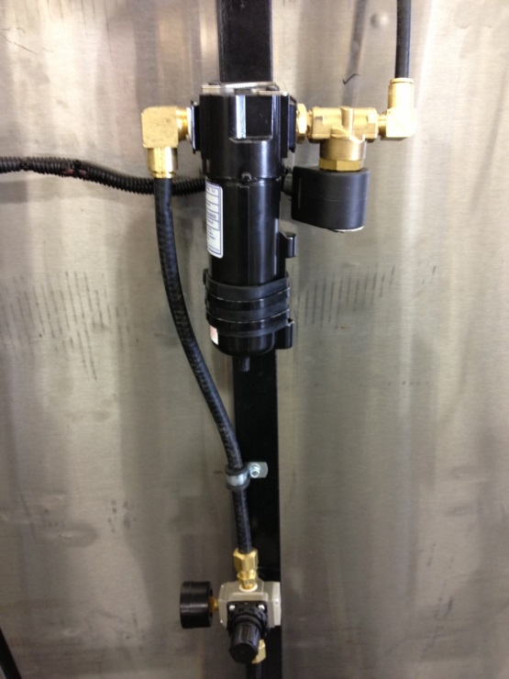

Mount temperature switch inside of VFD enclosure on the upper right side of box. When wiring in switch, connect supplied capacitor in parallel with switch leads.

*Figure 6. Temperature Switch*

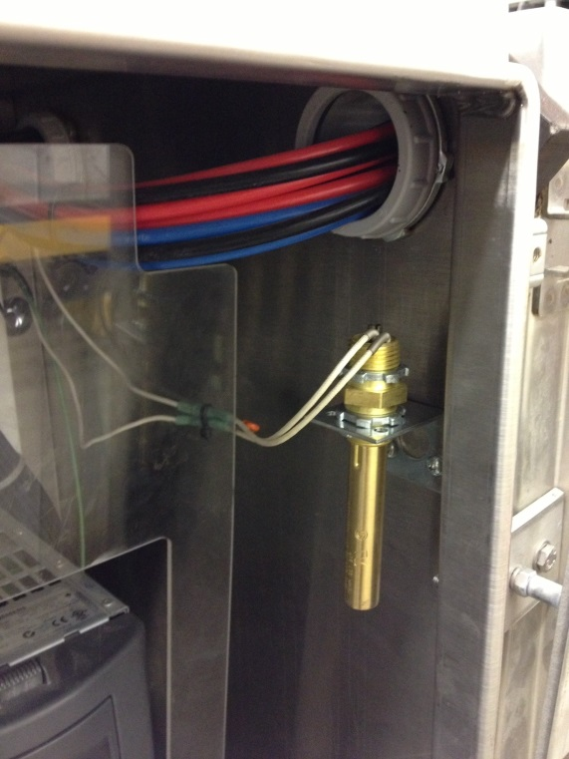

24V power is supplied by the PLC’s AC/DC power converter. All components (temperature switch and solenoid) are wired in series.

*Figure 7. Power Supply.*

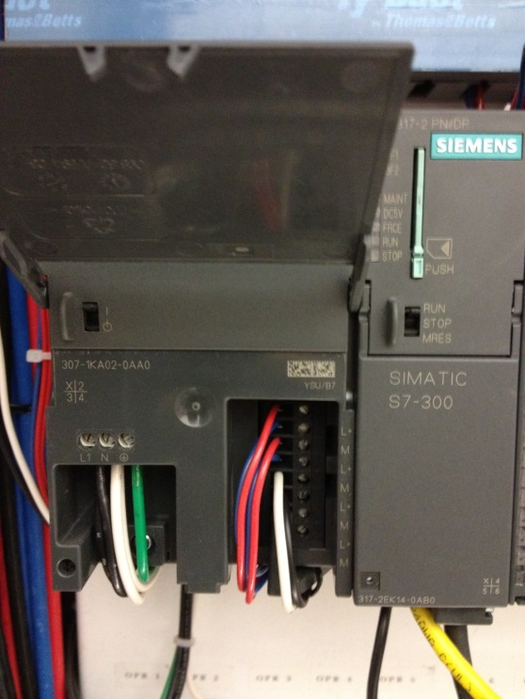

Drill a small hole in the upper part of the panel in order to connect wiring for solenoid. The solenoid is not polarity sensitive, the green wire is tied to a common ground in the panel. Also drill a small hole underneath this to install the panel vent.

*Figure 8. Solenoid Wiring and Vent*

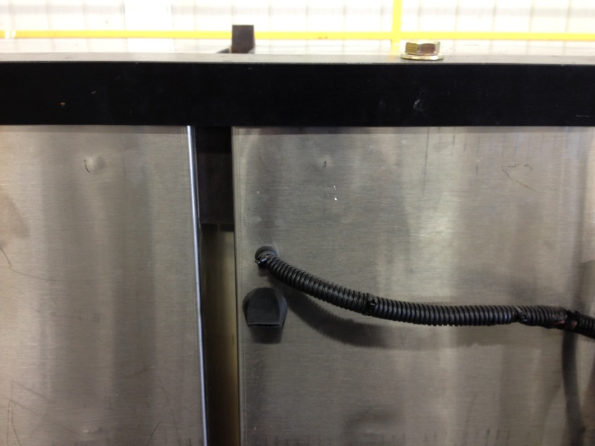

Install the analog thermometer on the front of the panel near the bottom left corner.

*Figure 9. Thermometer*

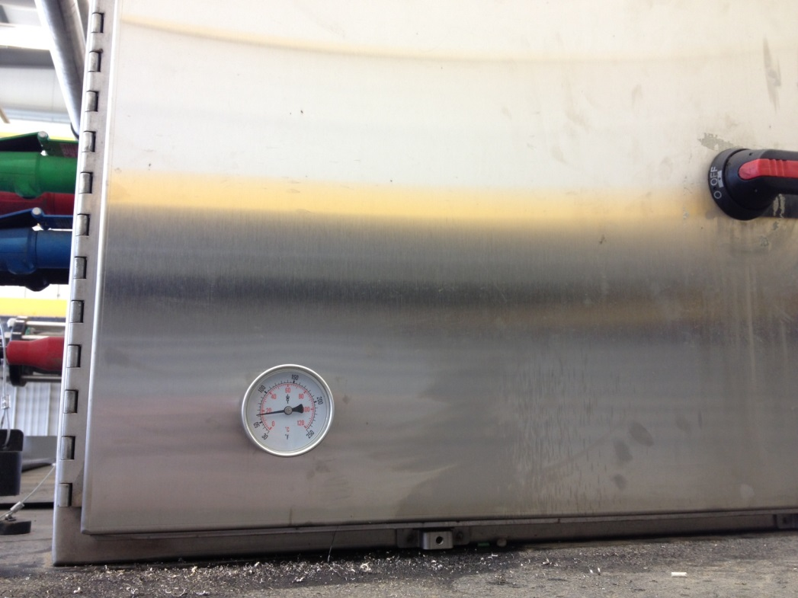

Once installation is complete, turn the thermoswitch set screw ¼ turn counter-clockwise turn to allow it to activate at a lower temperature. The pressure regulator should be set to 40psi. Test the setup using a sensitive thermometer. The system should activate when the temperature reaches 25⁰C and shut off around 20⁰C.