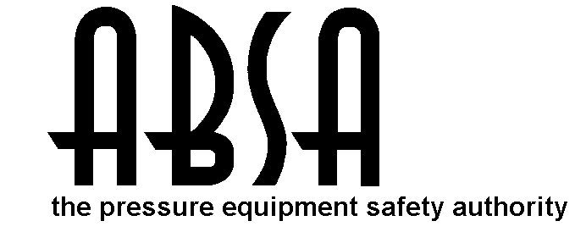
Pressure Piping Construction and Test Data Report

In accordance with the provisions of the PESR Section 31(1)

Shop Construction ; Field Construction ;
Final Data Report ; Partial Data Report (from one ABSA- authorized Contractor to another ABSA- authorized Contractor).

Complete both sides of this Form

1. Constructed By: Enerflex Ltd. Owner’s Job No: 10569
(Name of ABSA authorized primary contractor or subcontractor)
3615-34th Street NE Calgary, Alberta T1Y 6Z8
(Address)
Certificate of Authorization Permit No. AQP-1032(S) Expiry Date: December 07, 2015

2. Constructed For: N/A
(Name of primary contractor if different from above)
N/A
(Address)
Certificate of Authorization Permit No. AQP-N/A Expiry Date: N/A
(Required when the primary contractor undertakes some/all of the quality functions, e.g., NDE, PWHT, Tie-in, fabrication, hydro test, final assembly etc.)

3. Owner: Enerflex Ltd Rentals 3615-34th Street NE Calgary, Alberta T1Y 6Z8
(Name and address)
Stock
(Location of installation)
Certificate of Authorization Permit No. AQP- NA Expiry Date: NA
(Required when the owner undertakes some/all of the quality functions, e.g., NDE, PWHT, Tie-in, fabrication, hydro test, final assembly etc.)

4. Piping Design Alberta Registration No.: PP-
(Required if aggregate piping volume is over 0.5m³)
5. Design Responsibility: Owner ; Contractor

6. WP No.: WP-496.2 ; Company: Enerflex Ltd. Owner’s WP No. (If used): WP-NA
(Alberta Registration No.) (Alberta Registration No.)
WPS No(s). used: - ; Owner’s WPS No(s). (If used):

7. Code: ASME B31.1 Non Boiler External Piping ; ASME B31.1 Boiler External Piping ;
B31.5 ; B31.9 ; CSA Z662 Steam Pipelines ;
ASME B31.3 - Service Category: Normal , D , M , High Pressure ; Severe Cyclic Condition
High Purity

Drawing No.  Rev. No.  Line No. | Fluid  (Air/Stm.  Etc.) | Des.  Press.  Psi | Des.  Temp.⁰F  (Max. & Min.) | Pressure  Test  Psi | Test  Medium | Pipe Mat'l  Spec. &  Grade | C.A.  in | Pipe NPS &  Schedule | Flange Material &  Rating | PWHT/  Preheat  Temp. ⁰F | NDE
START AIR  FUEL GAS | GAS | 150 | 130°F | 225 | WATER | SA106B | 1/8 | 2” XH  1 ½” XH | - | - | Visual
BYPASS | GAS | 1310 | 300°F | 2220 | WATER | SA106B | 1/8 | 1” 160 | SA105N  CL.600 | - | Visual

Partial Data Reports certified by sub-contractors are listed below and attached to this Data Report

No. | Line No. | Spool No. | Dwg. No.  (with Rev. No.) | Sub-contractor  (Name) | AQP No.  (if from Alberta) | Expiry  (if from Alberta)

Remarks: For partial data report provide information about the code work that was not completed by the subcontractor (e.g., hydrostatic test, PWHT etc.). For final data report provide information about the code work that was not completed by subcontractors and subsequently completed by the primary contractor (e.g., hydrostatic test of entire assembly, PWHT etc.)

Endorse certificate ‘A’ or ‘B’
A. CERTIFICATE OF COMPLIANCE  Signed by the subcontractor when supplying this certificate as a  Partial Data Report  We certify that the statements in this Data Report are correct and that materials, construction and workmanship of the piping fabrication conform to the registered quality system and the applicable Piping code(s).  Date:  Contractor  Print Authorized Representative’s Name Signature  This certificate is not valid unless it forms part of a Final Data Report signed by Primary Contractor | B. CERTIFICATE OF COMPLIANCE  Signed by the primary contractor when supplying this certificate as a  Final Data Report  We certify that the statements in this Data Report are correct and that piping job no. 10569  described in this Data Report was constructed in accordance with the Province of Alberta Safety Codes Act and Regulations, and applicable ASME Piping Code(s).  Date:Feb. 06, 2013 Enerflex Ltd.  Contractor  Dennis M. Serrano  Print Authorized Representative’s Name Signature

CERTIFICATE OF INSPECTION
I, the undersigned, employed by Enerflex Ltd. have verified that all required examination and testing has been completed, and inspected the piping described in this construction data report to the extent necessary to be satisfied that it conforms to all applicable examination requirements of the Code and of the engineering design, and state that, to the best of my knowledge and belief, the contractor has constructed this piping in accordance with the Alberta Safety Codes Act and Regulations. By signing this certificate neither the inspector nor his or her employer makes any warranty, expressed or implied, concerning the piping described in this construction data report. Furthermore, neither the inspector nor his or her employer shall be liable in any manner for any personal injury or property damage or a loss of any kind arising from or connected with this inspection.

Date: Feb. 06, 2013 Date:

Dennis M. Serrano
Owner’s Inspector Name (please print) ABSA Safety Codes Officer (please print)
(BOILER EXTERNAL PIPING ONLY)

Owner’s Inspector Signature: ABSA Safety Codes Officer’s Signature
Current version of this Form may be obtained from www.absa.ca

