Client | Taqa North | Work Location | Chinchaga Gas Plant B.C./ c32h-94h8
Client Representative | Terry Fleet/ Mike Johnston | Date of Inspection | July, 22-24, 2012
WO#  PO # | 1120624 9038 669 160341 | Report Number  Client # | RP-001PAUT- Bullet # 603-VP-006  AB-103
Reference Specifications | ASME VIII APENDIX 12 DIV 1 | Acceptance Criteria | Client Information
Item Inspected | Bullet # 603-VP-006 | Material Type  Material Grade | Carbon Steel  (shell)SA-612-B/(heads)SA-455-B
Equipment Line #  Unit # | 603-VP-006  603-VP-006 | Location #  Plant | c32h-94h8  Chinchaga Gas Plant
Welding Contractor  Weld Type | N/A  Various | Welder / ID  Weld Electrode  Weld Procedure | N/A  N/A  N/A
Inspection Method | PAUT  MUT | Procedure  Technique | FOCUS-AUT-04C-09 Rev 2  FOCUS UT-04-09 Rev 2
Technician  Assistant | R.Petrie  Hachim Hachim | Qualifications | SNT/CGSB UT2/MT2/PT2/ PCN PAUT2/TOFD2  Scanner Technician

Examination Settings
Method: |  | Contact Immersion Other: |  |  |  |  |  |  |  |  |  |  |  | Surface Temp (C): < 5° > 45°/ < 45° > 60°
Type: |  | PE T/T Dual Automated PAUT |  |  |  |  |  |  |  |  |  |  |  | Scanning Surface: OD ID Other:
Application: |  | Laminar Shear Wave Volumetric Thickness |  |  |  |  |  |  |  |  |  |  |  | Surface Condition: Painted - Acceptable
Instrumentation: |  |  | Manufacturer: |  |  |  | OLYMPUS |  |  |  |  | Type: | OMNISCAN |  |  | Instrument Ser. #: |  |  | OMNI-100504
Calibration: |  | Date: |  |  | July-05-2012 |  |  | Reference Flaw Size: |  |  |  |  | 3mm |  |  | FOCUS #: |  |  | N/A
Instrumentation: |  |  | Manufacturer: |  |  |  | OLYMPUS |  |  |  |  | Type: | EPOCH XT |  |  | Instrument Ser. #: |  |  | 101343806
Calibration: |  | Date: |  |  | July-05-2012 |  |  | Reference Flaw Size: |  |  |  |  | 3mm |  |  | FOCUS #: |  |  | N/A
Calibration Block(s): |  |  |  |  | Type: | DSC/IIW |  |  |  | FOCUS #: |  |  | A01419 |  | Type: | PAUT001 |  | FOCUS #: |  | 2010-05
Couplant: | Brand: |  |  | H2O |  | Type: |  | Water |  |  |  |  | Cable: |  | Type: | Coaxial |  | Length: |  | 72”
 |  |  |  | SONOTECH |  | Type: |  | 2 PART MIX |  |  |  |  | Cable: |  | Type: | Umbilical |  | Length: |  | 75’
Probe |  |  |  |  |  |  |  |  |  |  |  |  | Settings – Db |  |  |  | Range - inches mm
Manufacturer |  | Type |  |  | Serial # | Angle |  |  | Freq. |  | Size |  | Reference Level |  | Scanning Level | Transfer Value | Screen  Size |  | Skip Value |  | Beam Travel
OLYMPUS |  | 5L-64-A2 |  |  | G1242 | 40°-73° |  |  | 5MHz |  | 64 elements |  | 28dB |  | +6dB | N/A | Variable |  | Variable |  | Variable
OLYMPUS |  | 5L-64-A2 |  |  | G2618 | 40°-73° |  |  | 5MHz |  | 64 elements |  | 27dB |  | +6dB | N/A | Variable |  | Variable |  | Variable
OLYMPUS |  | 5L-16-A1 |  |  | F0951 | 45°-73° |  |  | 5MHz |  | 16mm |  | -29.95dB |  | +6dB | N/A | Variable |  | Variable |  | Variable
PANAMETRICS |  | C550-SM |  |  | 785977 | 60° |  |  | 3.5MHz |  | 9.52mm |  | 42.6dB |  | +6dB | 0dB | 80mm |  | 46.7 |  | 57.8
PANAMETRICS |  | C550-SM |  |  | 789656 | 70° |  |  | 3.5MHz |  | 9.52mm |  | 48.8dB |  | +6dB | 0dB | 100mm |  | 66.73 |  | 74.89

SCOPE:
Carry out Phased Array & Manual Ultrasonic Examination on client requested circumferential and long seams on Bullet # 603-VP-006. The examination shall consist of Phased Array Sectorial (40° thru 73°), Manual Ultrasonic 60° & 70° scanning where the AUT Scanner cannot reach due to vessel geometries & a transverse scan of all welds examined. AUT scanning shall cover the volume of the weld and associated heat affected zones to detect, locate and size all flaws. Report all relevant indications and analyze in accordance with client specifications (ASME SECTION VIII DIVISION 1 APPENDIX 12 acceptance limits).

Figure 1: Bullet-603-VP-006

SUMMARY OF RESULTS

Six (6) long seam welds were scanned on both east and west heads (thickness 11mm) of 603-VP-006. Included in the head examinations was the round nose weld on the ends of the vessel. Processing indications (e.g. Slag) were present in these welds. Refer to Figure’s 3-6. No cracking was found in these areas on the vessel.

Cs1 was examined by Phased array. Included in this examination was 600mm of Ls1 including the tee weld as it ties into Cs1. Zero indications of concern were found in this weld.

600mm of Ls3 was examined by Phased array. The scan started where Ls3 and Cs4 meet. Welds were free and clear from any recordable indication.

Cs4 was examined with Phased array in two (2) 1500 mm scans. From TDC (top dead center of the vessel) North (scan 1) past Ls3 and south (scan 2) past Ls4. Welds were free and clear from any recordable indication.

600mm of Ls4 was examined by Phased array. The scan started where Ls4 and Cs4 meet. Welds were free and clear from any recordable indication.

Cs7 was examined by Phased array. Included in this examination was 600mm of Ls6 including the tee weld as it ties into Cs7. Zero indications of concern were found in this weld

- Summary of 0° UT Thickness Inspection:
A UT thickness measurement reading was performed prior to this examination. The majority of readings were found to be in the range of (17.0mm) on vessel shell & (11.0mm) on the vessel Head.
- Summary of Shear Wave Inspection:
Manual Shear wave was carried out on all suspect areas of the welds, utilizing a 60° and 70° probe or Manual Phased array to detect, locate and characterized all defects.

.
Figure 2: Manual Shear Wave (60°/70°) scan pattern

- Summary of Phased Array Examination:
PAUT scan was performed on the client requested circumferential & long-seam welds. This examination was performed to detect and locate any weld defects such as ID cracking due to use of vessel through-out production.

CONCLUSION:
All indications found with PAUT were further examined, evaluated and confirmed with manual ultrasonic testing. Processing indications were found during examinations of vessel and will be reported on final report to allow for future monitoring. No cracking was found during this examination of Bullet 603-VP-006

Respectfully submitted by, R.W. Petrie

Report Accepted by: ____ Terry Fleet/ Mike Johnston

PAUT Scan Plans

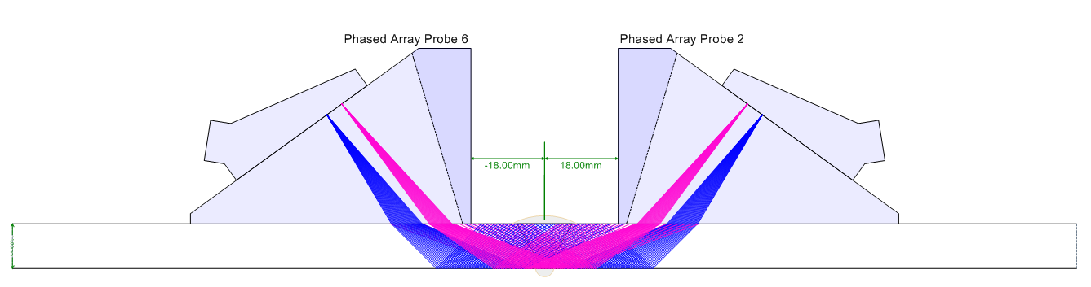

Figure 3: 11mm Head Scan plan

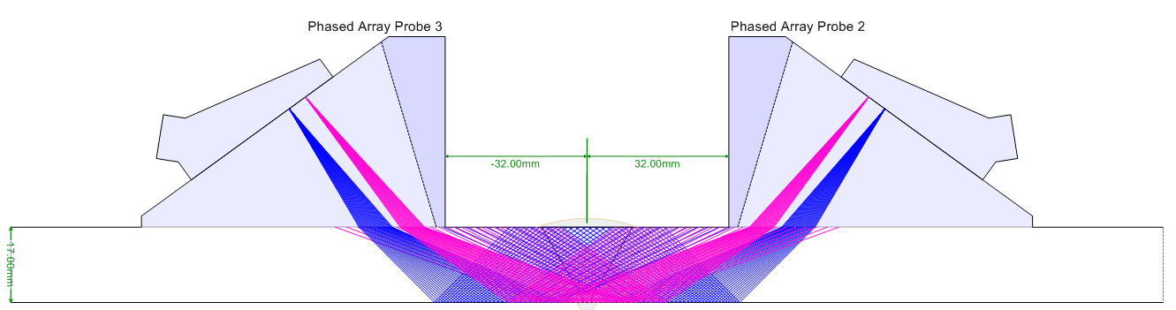

Figure 4: 17mm Shell Scan plan

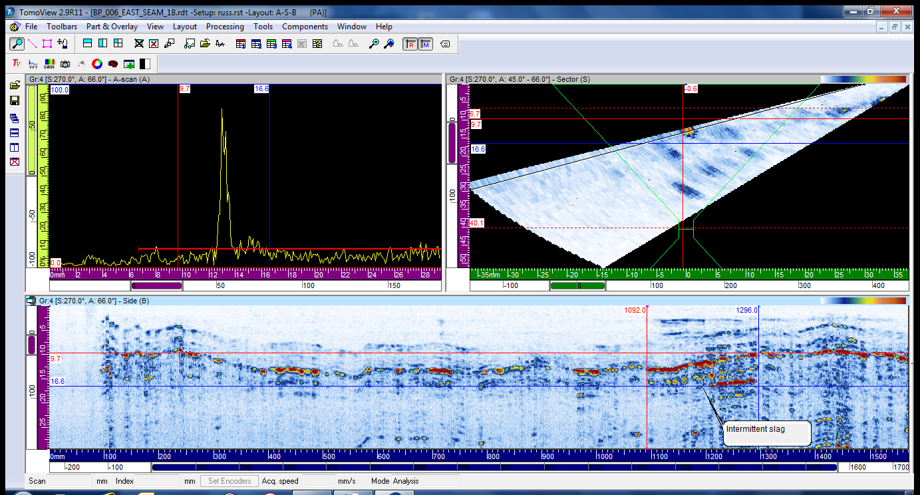
Figure 3: East Head Seam # 1

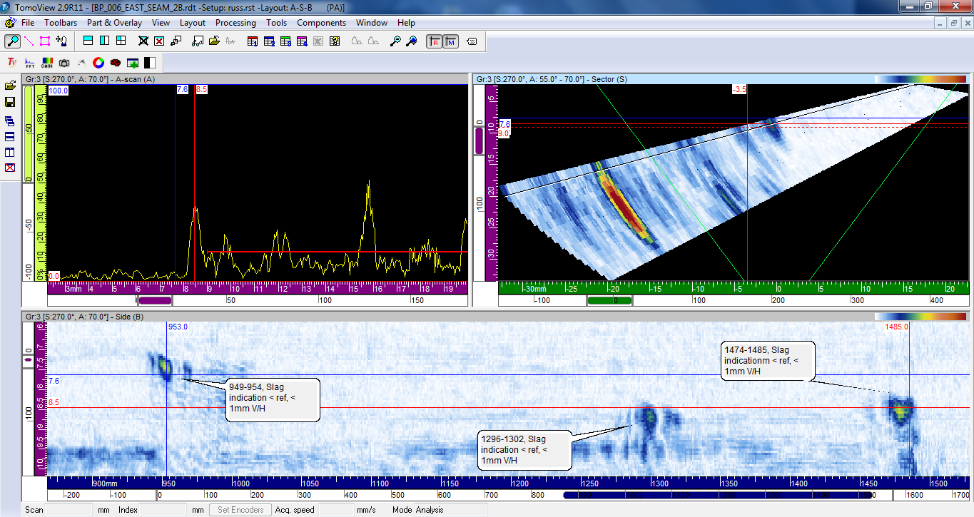
Figure 4: East Head Seam # 2
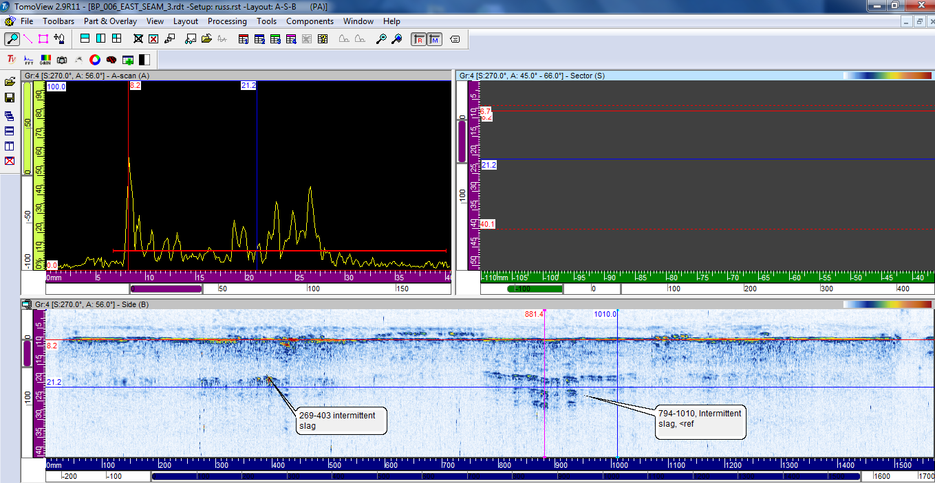
Figure 5: East Head Seam # 3

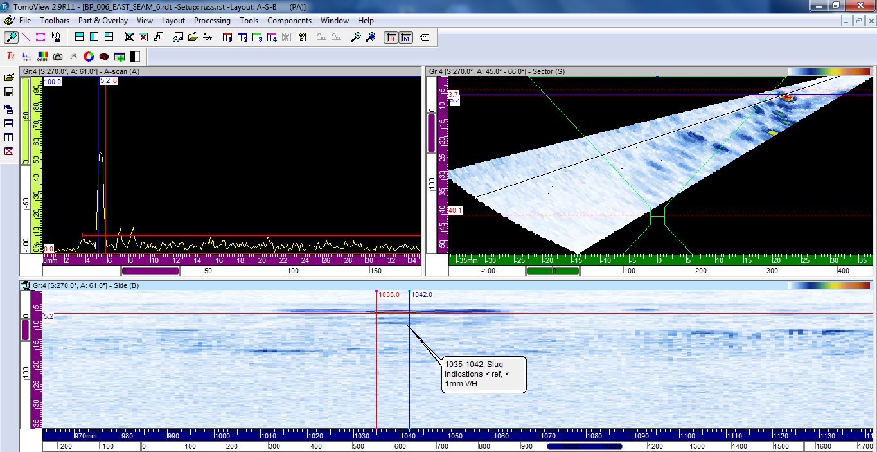
Figure 6: East Head Seam # 6

