Facility: |  | Chinchaga C-32-H/94-H-8 |  |  |  |  |  |  |  |  | PRN: |  |  |  | PV69P8797 (BC) |  |  |  |  | Date of Inspection: |  |  |  |  |  |  | 8-Jun-2017
Equipment Type: |  |  | Separator (BC #1) |  |  |  |  |  |  |  |  |  |  |  |  | Field Tag #: |  |  |  |  |  |  | 603VS008
Service: | ☐Sour ☒Sweet ☐Cryogenic ☐Air ☐Steam |  |  |  |  |  |  |  |  |  |  |  |  |  |  | MAWP: |  |  | 275 PSI @120F
Fluid: | Emulsion |  |  |  |  |  |  |  |  |  |  |  |  |  |  | Manway |  |  | ☒ Yes |  |  |  |  | ☐ No |  | Size of Manway
Scope of Inspection: |  |  |  |  | Type of Inspection: |  |  |  |  |  |  |  |  |  |  |  |  | Cleaning: |  |  |  |  |  |  |  | Access:
☐ Pre-commissioning |  |  |  |  | ☐ AE |  |  |  | ☐ MT |  |  |  | ☐ RT |  |  |  |  | ☒ Good |  |  |  |  |  |  |  | ☒ Full
☐ Initial |  |  |  |  | ☐ ET |  |  |  | ☐MFL |  |  |  | ☐ UT |  |  |  |  | ☐ Fair |  |  |  |  |  |  |  | ☐ Partial
☒ Re-inspection |  |  |  |  | ☐ LT |  |  |  | ☐PT |  |  |  | ☒ VT |  |  |  |  | ☐ Inadequate |  |  |  |  |  |  |  | ☐ External
 |  |  |  |  | ☐HT |  |  |  | ☐Other
Note: Add pages and sketches as needed
Observations: |  |  |  | ☐ External |  |  |  |  |  |  |  |  |  | ☒Internal
Internal:
- Manway free of pits
- Vessel is uncoated
- Manway shell is in excellent condition. No pitting observed.
- 1st stage of shell is in excellent condition circumferentially. Some general erosion corrosion on splash impact area from inlet diverter.
- 2nd stage (past weir) nozzles in good condition, no visible cracking or pitting.
- Weir in good condition
- Drain nozzle in good condition.
- No general corrosion observed, oily residue persistent throughout vessel surfaces.
- Glycol heat lines have stainless fittings and are in like new condition.
- Glycol heat trace lines are in fouled externally and unable to inspect. Small portion scraped and inspected has no pitting corrosion observed.
- Bottom end of shell is in good condition with no pitting observed. Nozzles in good condition, no pits or cracks.

External:

Recommendations:
Perform UT to determine remaining wall on vessel, particularly on splash area from inlet diverter.

Suitable for further service: |  |  |  | ☒Yes |  |  | ☐No |  |  | Remedial Action Priority Level: |  |  |  |  |  |  |  |  |  |  |  | ☐High |  |  | ☐Medium |  |  | ☐Low
Inspection Performed By: |  |  |  | Darren Isaac |  |  |  |  |  |  |  |  |  | Click here to enter text. |  |  |  |  |  |  | Date of Report: |  |  |  |  | 12-Jun-2017
Signature:
Follow Up Inspection Required: |  |  |  |  |  | ☐ Yes |  | ☒ No |  |  |  | By Date: |  |  |  |  | DD-Mon-YYYY

Pictures:

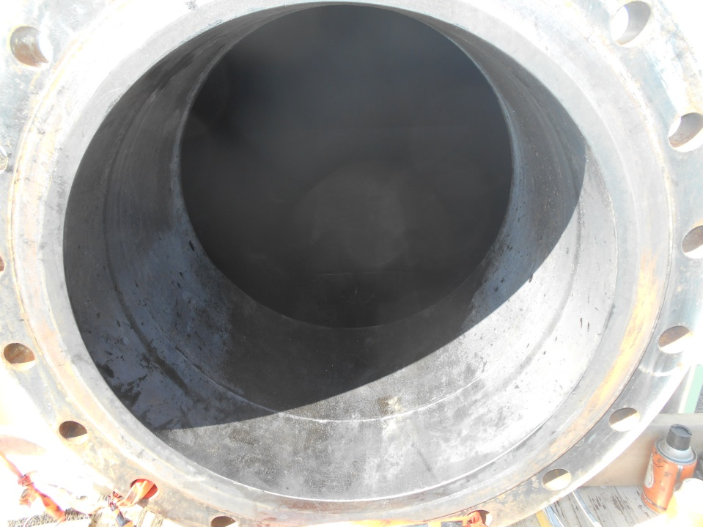
Figure 1 Manway
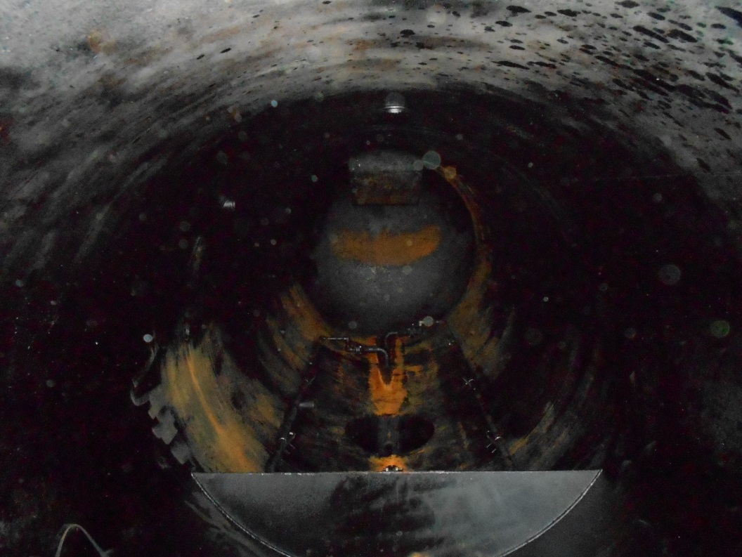
Figure 2 Internal Overview

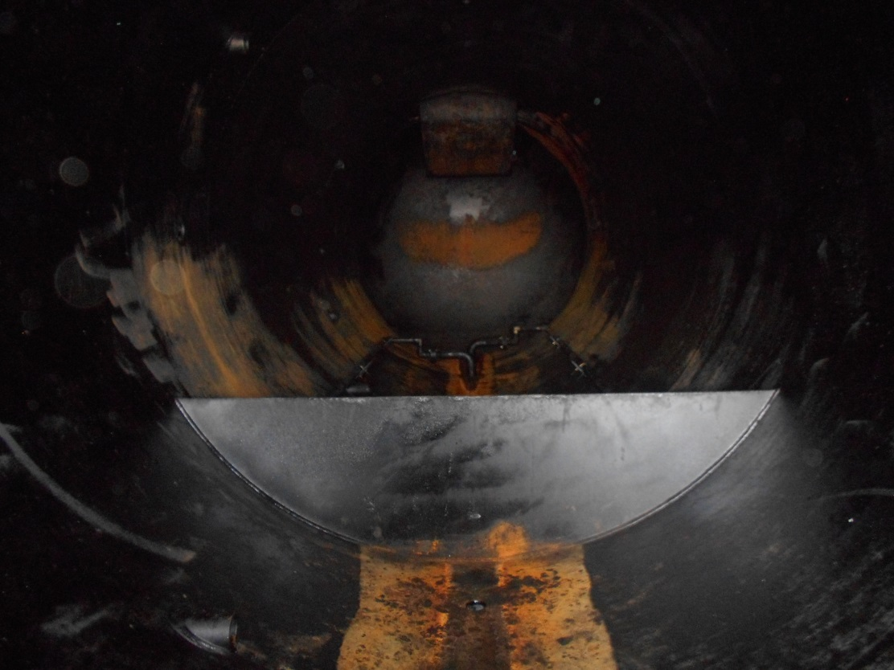
Figure 3 Weir

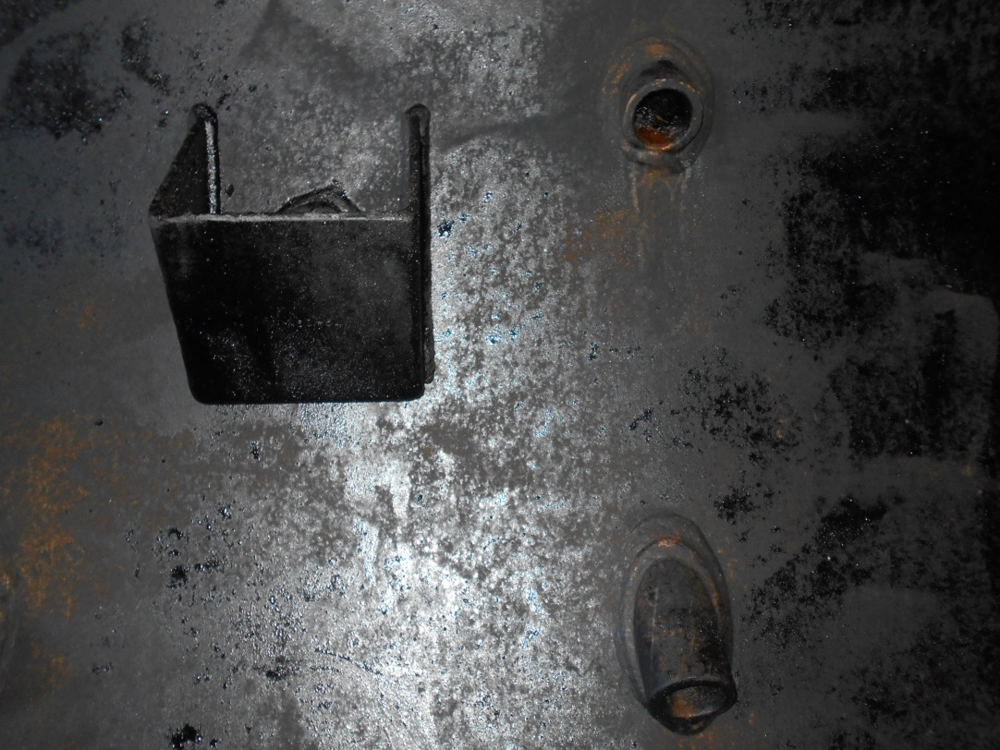
Figure 4 Nozzles

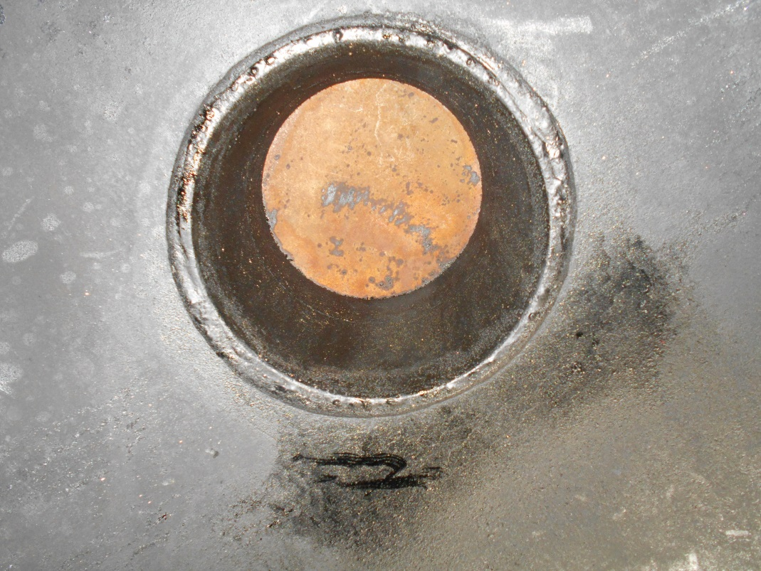
Figure 5 PSV Nozzle

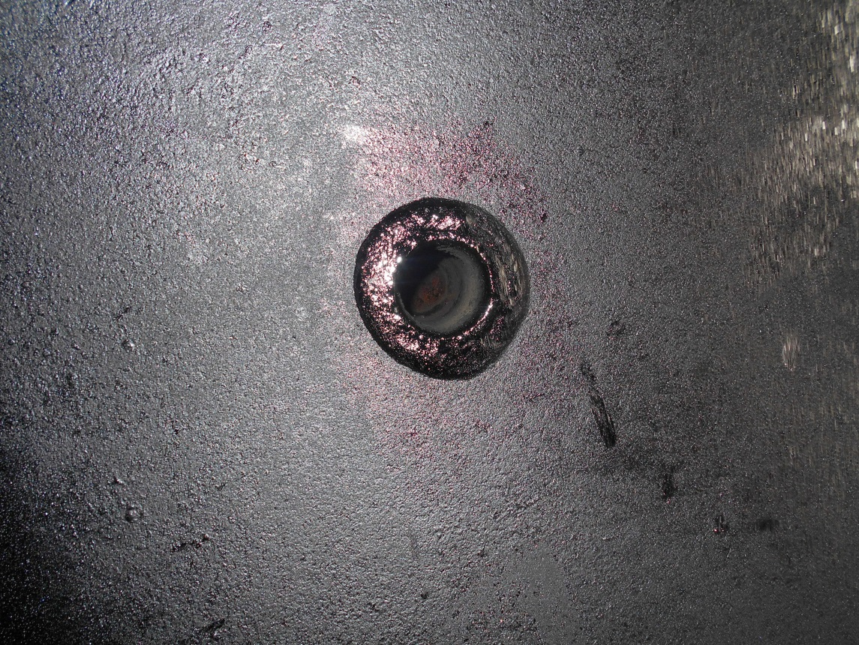
Figure 6 Upper Shell Nozzle

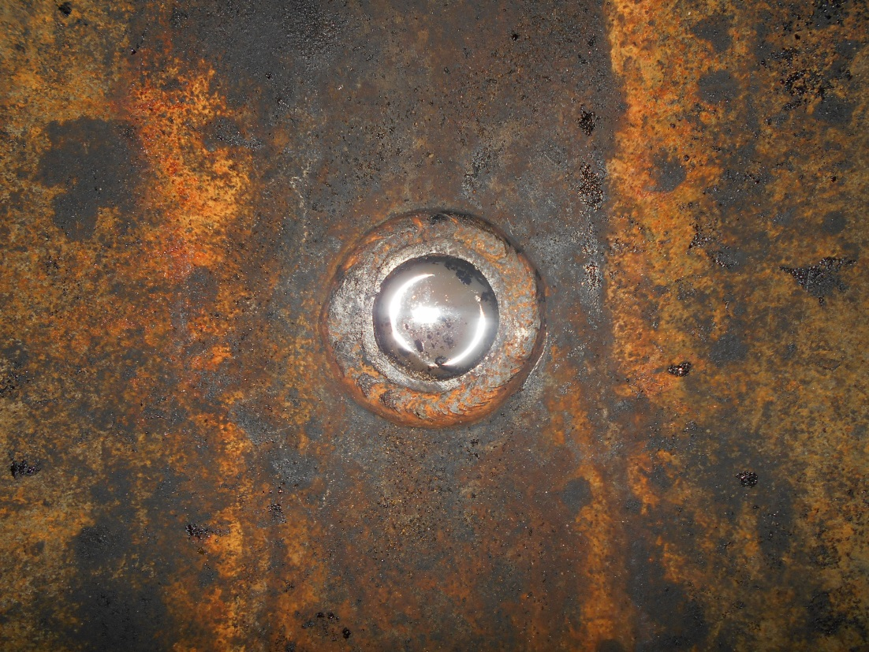
Figure 7 Lower Shell Drain Nozzle

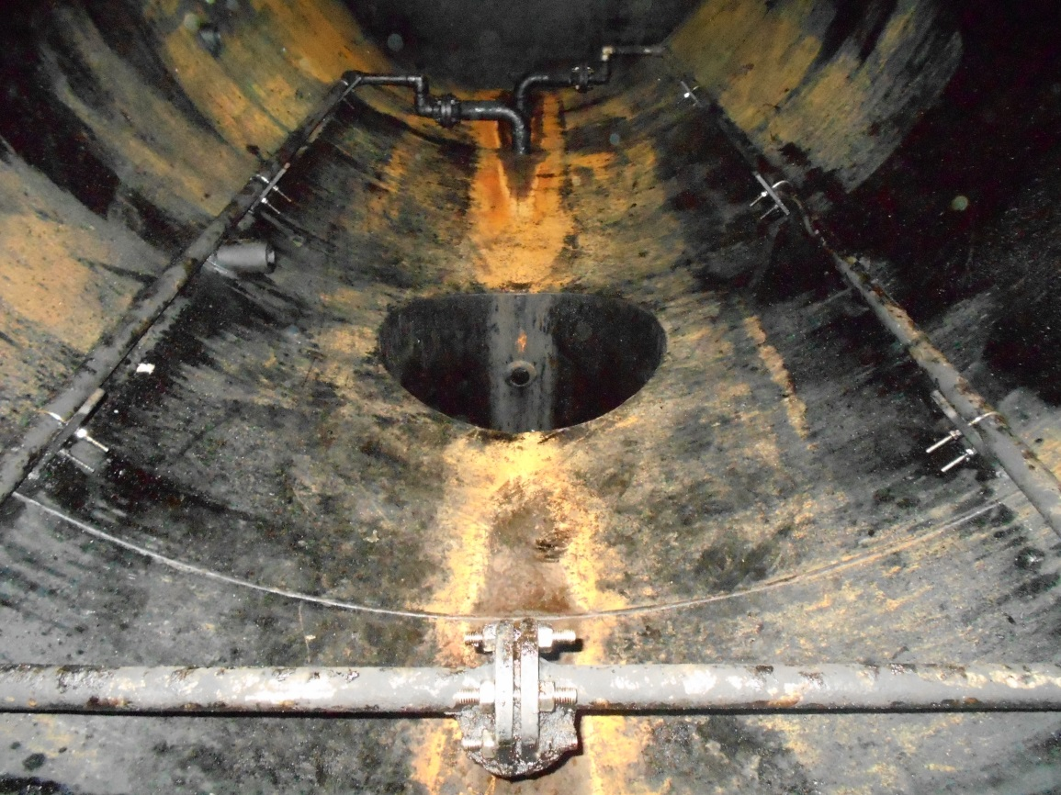
Figure 8 Glycol Heat Trace Lines and Boot

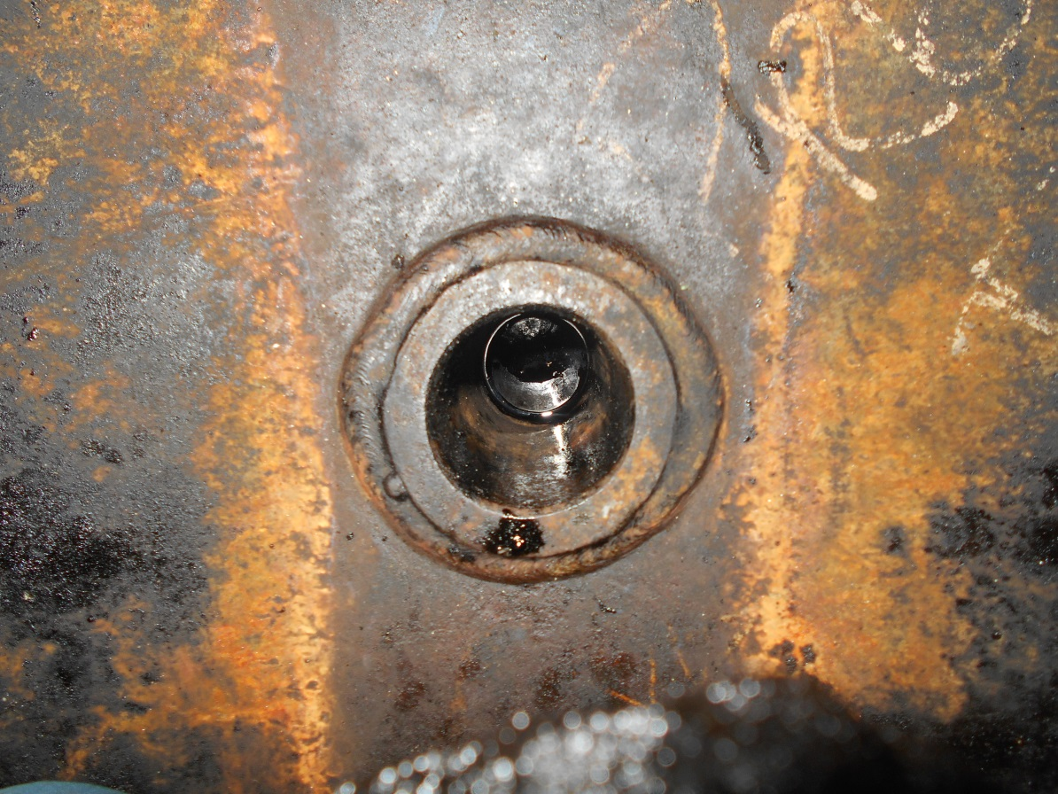
Figure 9 South Floor Drain Nozzle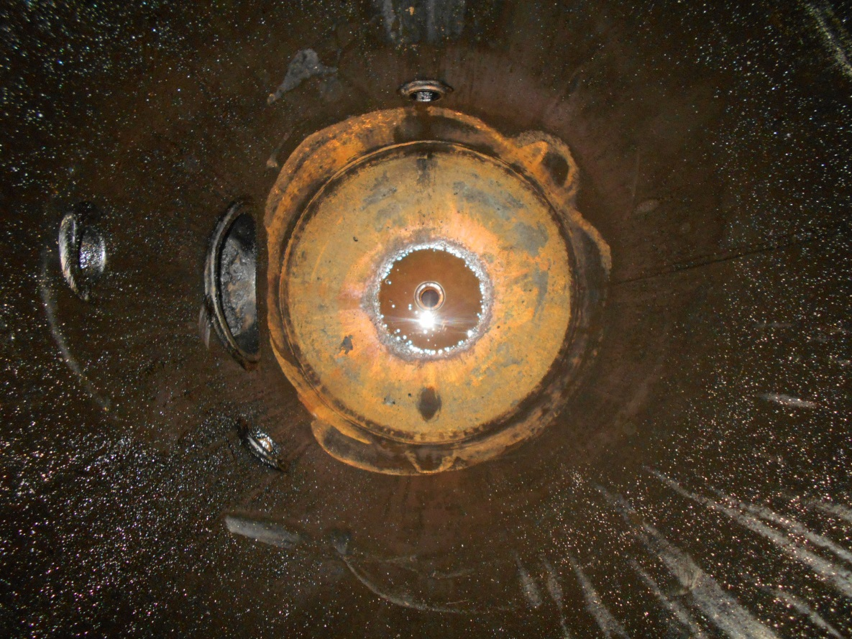
Figure 10 Looking Down Into The Boot

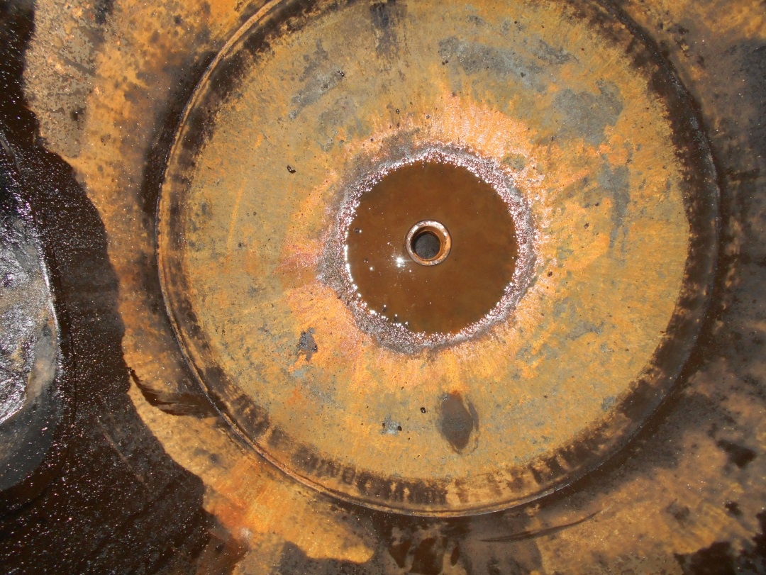
Figure 11 Lower Shell on Boot
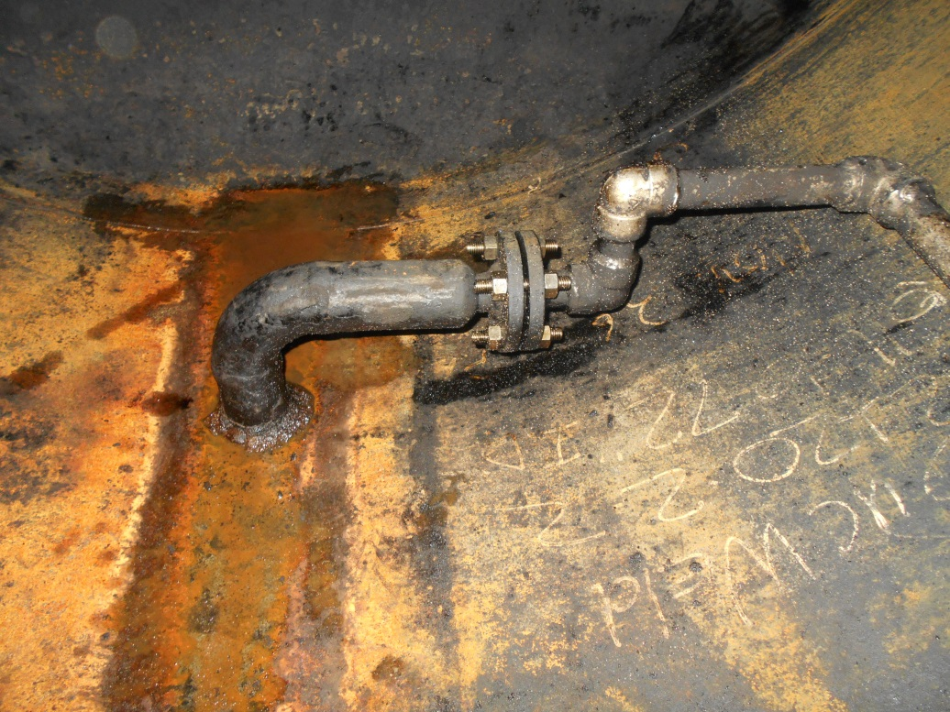
Figure 12 Glycol Heat Trace Nozzle and Piping

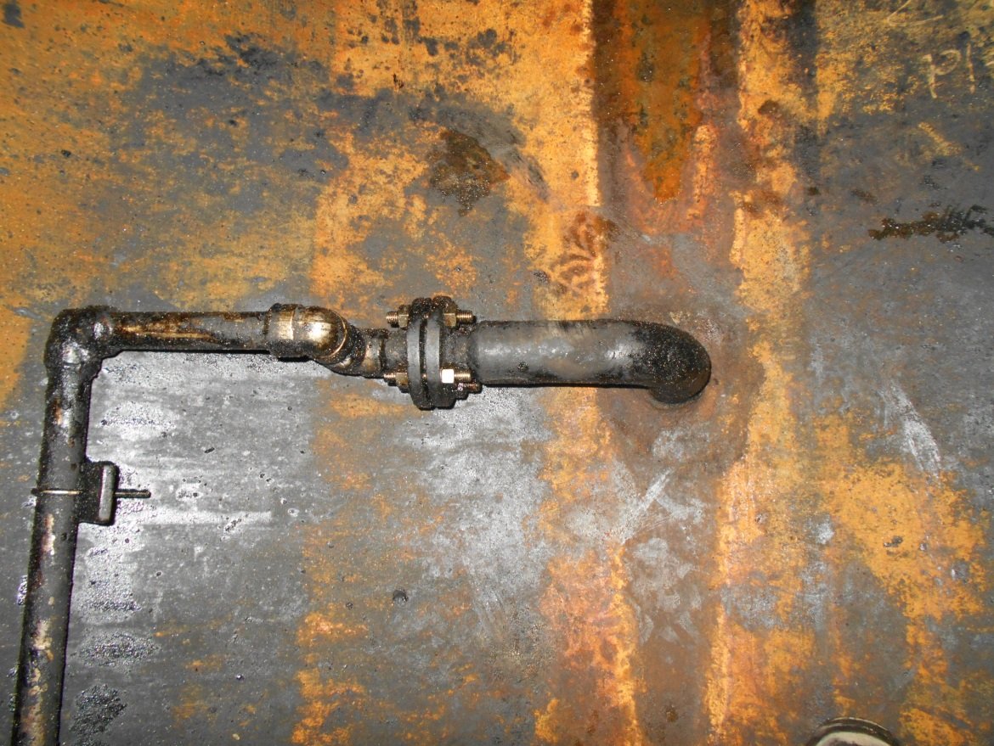
Figure 13 Glycol Heat Trace Nozzle and Piping Top View
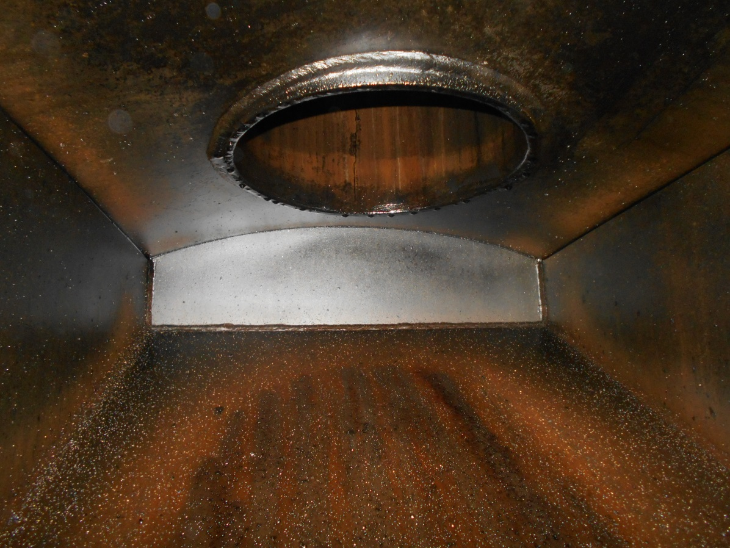
Figure 14 Inlet and Diverter Plate
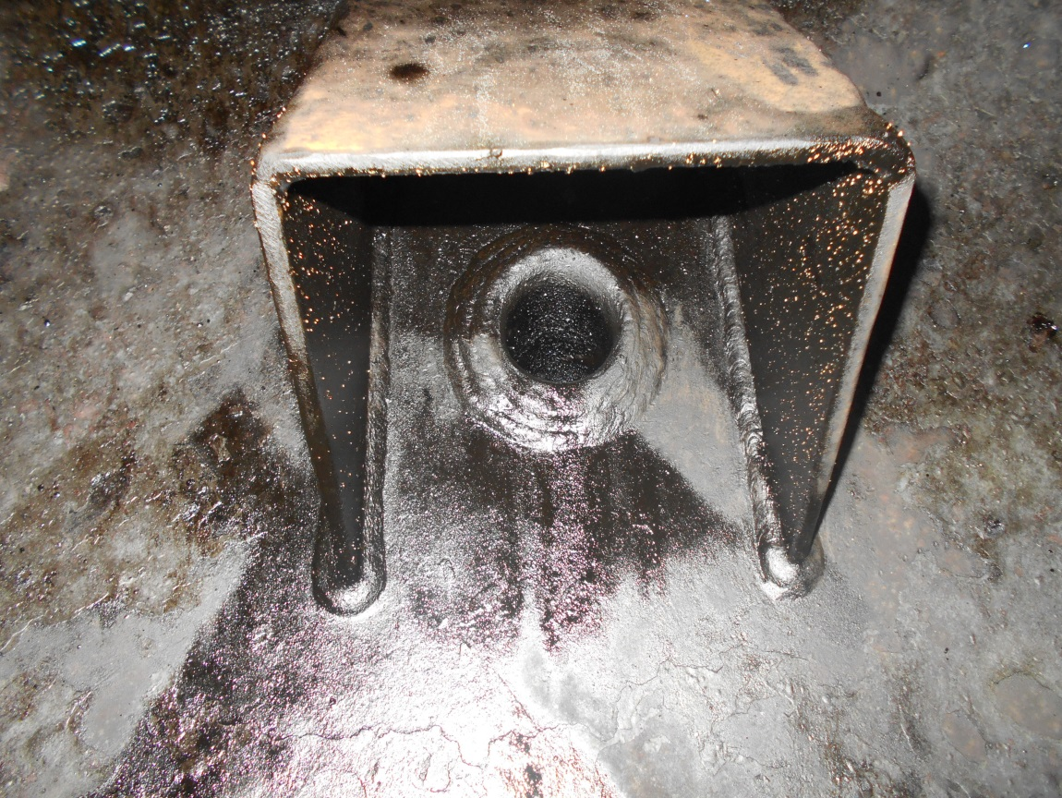
Figure 15 Nozzle Top Down view

