FACILITY: |  | Chinchaga Plant PLT/c-032-H/094-H-08/00 |  |  |  |  |  |  |  |  |  |  |  |  |  |  |  |  | PROV. REG. N0: |  |  |  |  | 570539
EQUIPMENT NAME: |  |  | Process Boiler Steam Generator |  |  |  |  |  |  |  |  |  |  |  |  |  |  |  |  | TAG NO: |  |  | 603FB001
SIZE: | 1524 mm |  |  | ID x |  | 3962 mm |  |  | L/H |  |  |  | L |  |  |  |  |  | MAWP: |  |  | 1379 kpa |  |  |  |  |  |  |  |  | kPa @ |  | 343 | °C
ITEM INSPECTED: Shell, Coil, Burner, Refractory, Insulation, Anchors, Manway. |  |  |  |  |  |  |  |  |  |  |  |  |  |  |  |  |  |  | MANWAY |  |  |  |  |  | YES |  |  |  | NO
SERVICE: sour sweet cryogenic |  |  |  |  |  |  |  |  |  |  |  |  |  |  | FLUID: Glycol/Fuel Gas
SCOPE OF INSPECTION |  |  |  |  |  |  | TYPE OF INSPECTION: |  |  |  |  |  |  |  |  |  | CLEANING: |  |  |  |  |  |  |  |  |  |  | ACCESS:
PRECOMMISSIONING |  |  |  |  |  |  | AE | MT |  | RT |  |  |  |  |  |  | GOOD |  |  |  |  |  |  |  |  |  |  | FULL
INITIAL |  |  |  |  |  |  | ET | MFL |  | UT |  |  |  |  |  |  | FAIR |  |  |  |  |  |  |  |  |  |  | PARTIAL
REINSPECTION |  |  |  |  |  |  | LT | PT |  | VT |  |  |  |  |  |  | INADEQUATE |  |  |  |  |  |  |  |  |  |  | EXTERNAL
 |  |  |  |  |  |  | OTHER
PLEASE ADD PAGES AND SKETCHES AS NEEDED (TURN OVER FOR SKETCH)
OBSERVATIONS: |  |  |  |  |  |  | EXTERNAL |  |  |  | INTERNAL
Internal:
Small loose metal slag noted around manway.
All anchors in place throughout vessel, anchors secure and showing no indication of degradation.
Coils tight and showing no signs of distortion, or indications of corrosion or mechanical damage.
Minor loose deposits between coils of insulation debris between the 11 coils at the burner end.
Refractory showing 4 thin cracks with no spalling at 12, 2, 5 and 10 O'clock.
Inner Rim refractory: Various refractory chips at 4, 5, 7-11. 0.150" Loss.
Outter Rim refractory: Various chips 10-3, largest section missing at 5 O'clock 45mm Wide x 115mm long x 15mm deep.
No exposed components through refractory. No detached pieces found in boiler.
Insulation clean and intact throughout. No visible components exposed.
Burner Assembly clean and secure. Burner tip clean and intact.
Manway gasket intact.
Signs of hot gas leakage at 12 O'clock on manway. Previously fixed with what appears to be application of HT Silicone.
RECOMMENDATIONS:
Return to service, monitory manway for hot gasses and seal appropriately, reinspect at appropriate interval.
UT performed by Rob Kassian, no low readings noted, report to follow.
SUITABLE FOR  FURTHER SERVICE: |  |  |  |  | YES |  |  | NO |  |  |  |  |  | REMEDIAL ACTION  PRIORITY: |  |  |  |  |  |  |  | HIGH |  |  |  | MEDIUM |  |  |  |  |  | LOW
INSPECTION PERFORMED BY: |  |  |  |  |  | Kevin Gawley, Reviewed Will Rettman |  |  |  |  |  |  |  |  |  |  |  |  |  |  | DATE OF INSPECTION : |  |  |  |  |  |  |  |  | July 17, 2012
 |  |  |  |  |  |  |  |  |  |  |  |  |  |  |  |  |  |  |  |  |  |  |  |  |  |  |  |  |  | (DAY-MONTH-YEAR)
FOLLOW-UP INSPECTION REQ’D: |  |  |  |  |  |  |  |  |  |  |  | YES |  |  |  | NO |  |  |  |  | BY DATE: :
 |  |  |  |  |  |  |  |  |  |  |  |  |  |  |  |  |  |  |  |  |  |  |  |  |  |  |  |  |  | (DAY-MONTH-YEAR)

1) External Overview of Vessel:
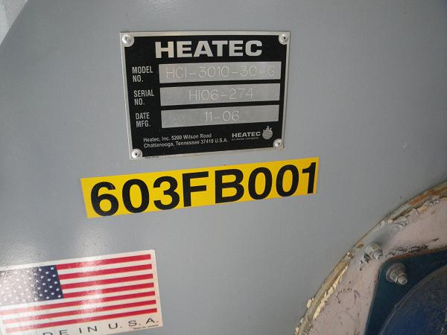

2) Manway towards Burner End Overview: (Liquid at 12, 3, 6 and 9 O’clock: UT Couplant)
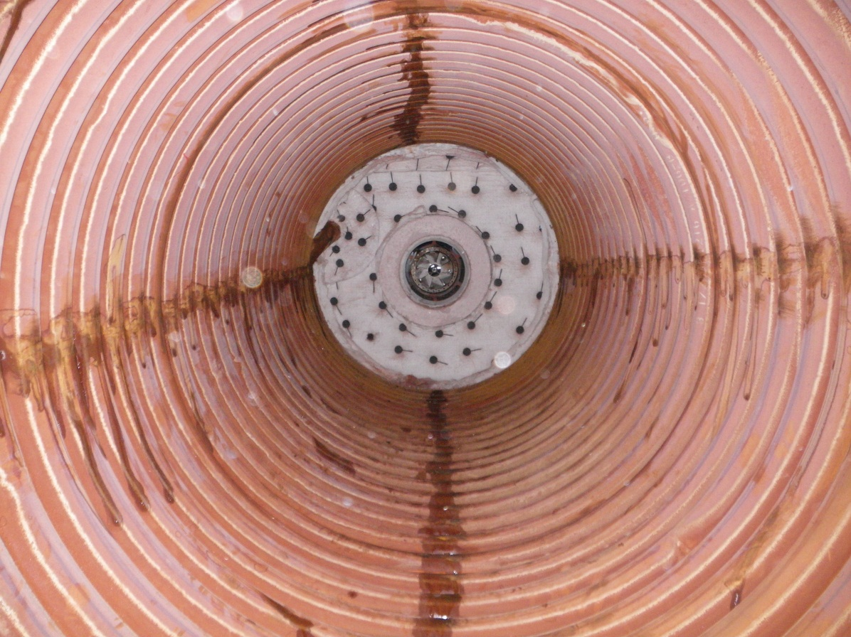

3) Slag and Debris around Manway; No visibly degraded sections of metal observed:
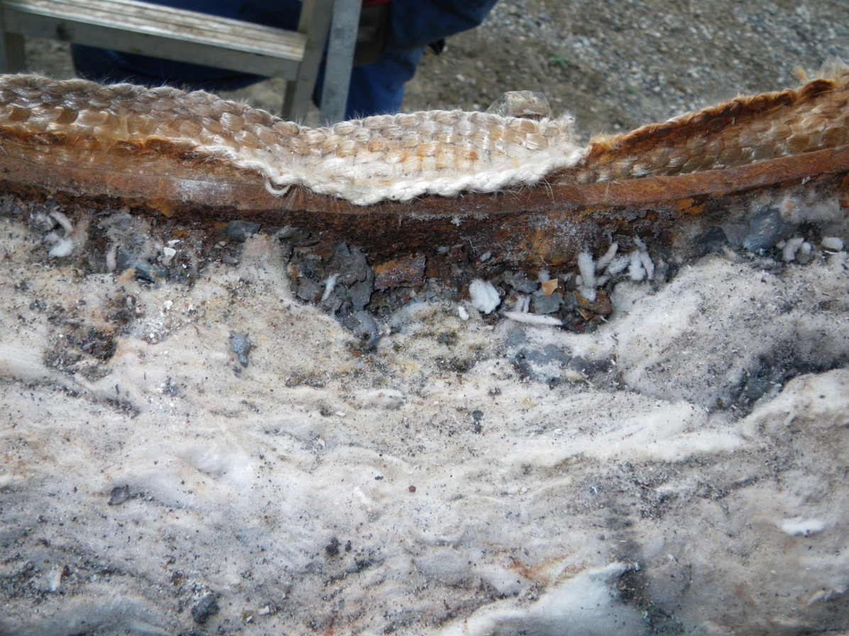

4) Minor bits of loose insulation noted between 11 coils at burner end:
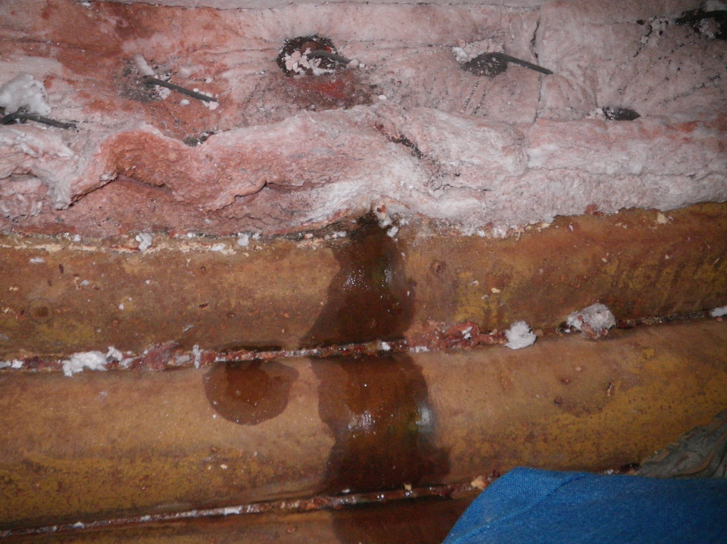:

5) Burner End Overview:
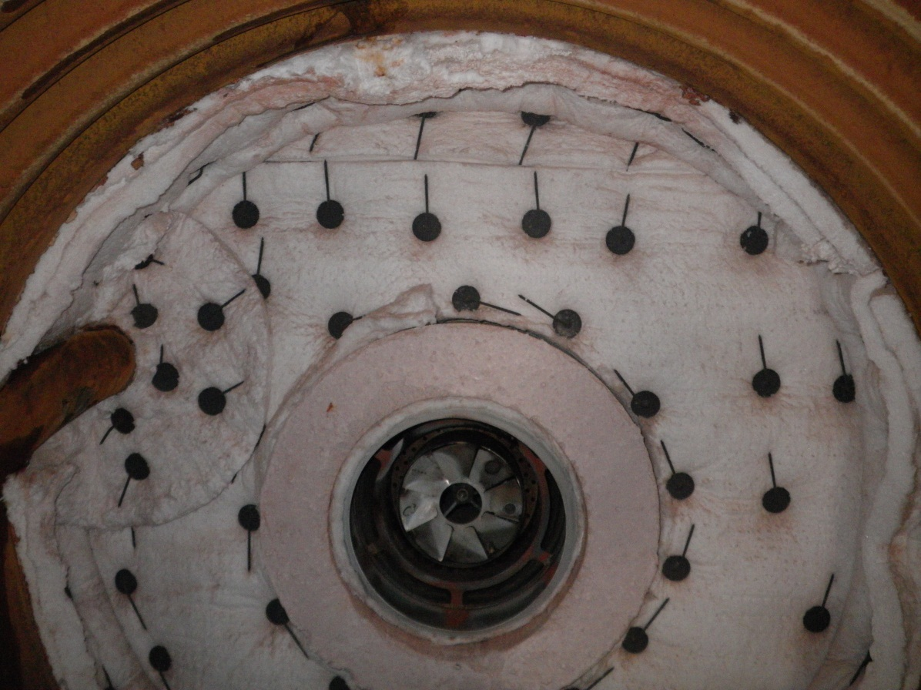:

6) Representative crack on refractory:
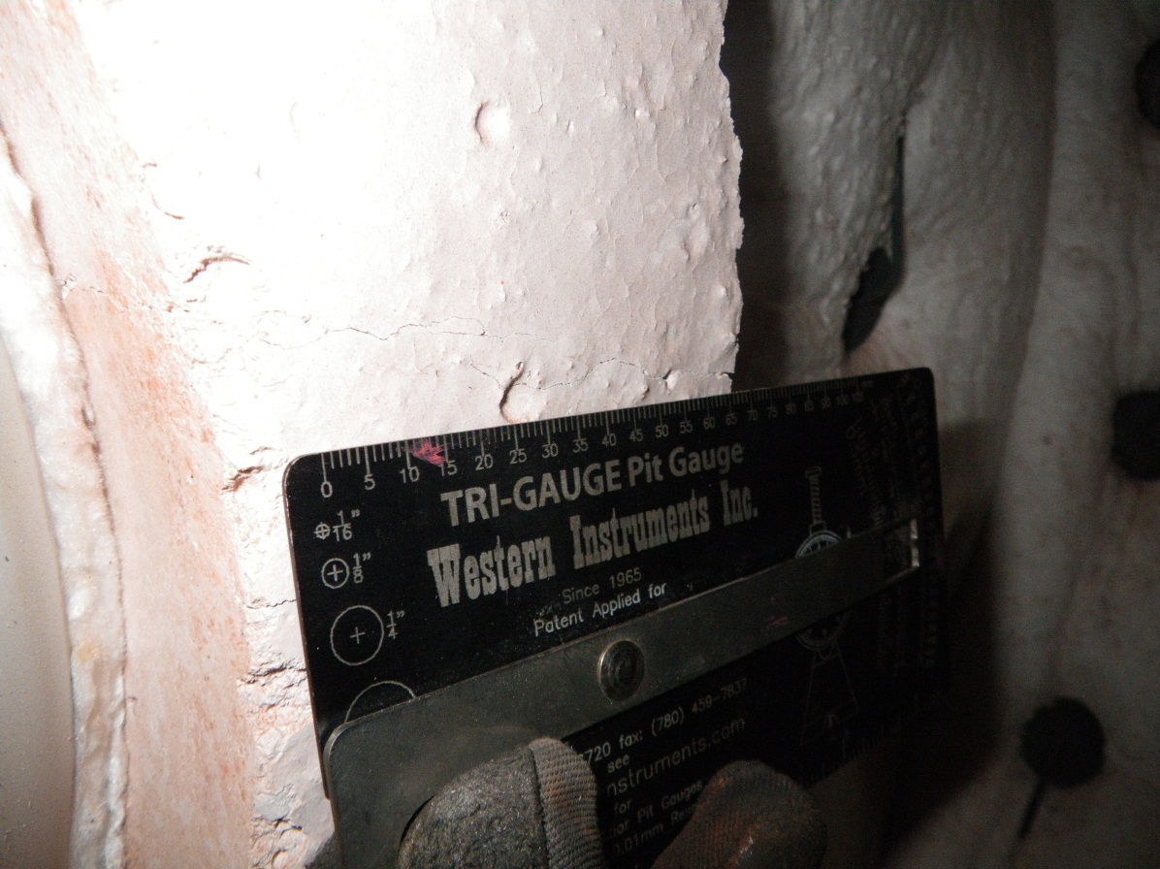:

7) Refractory Overview:
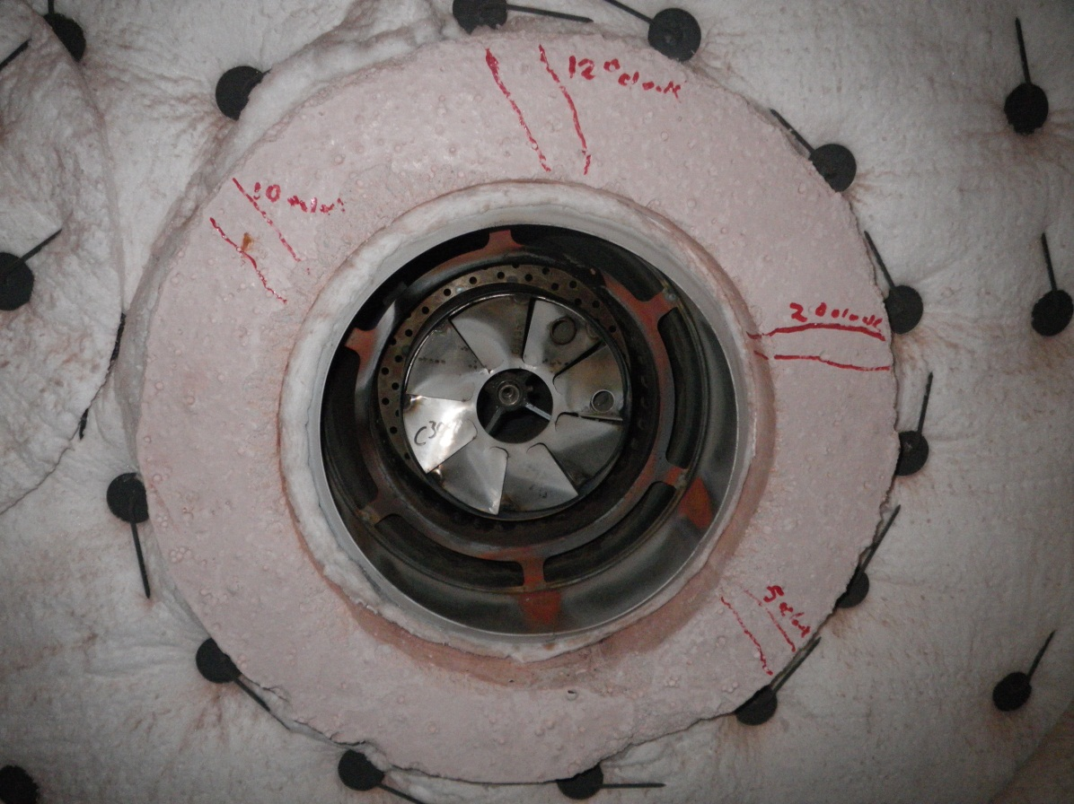
8) Missing Refractory
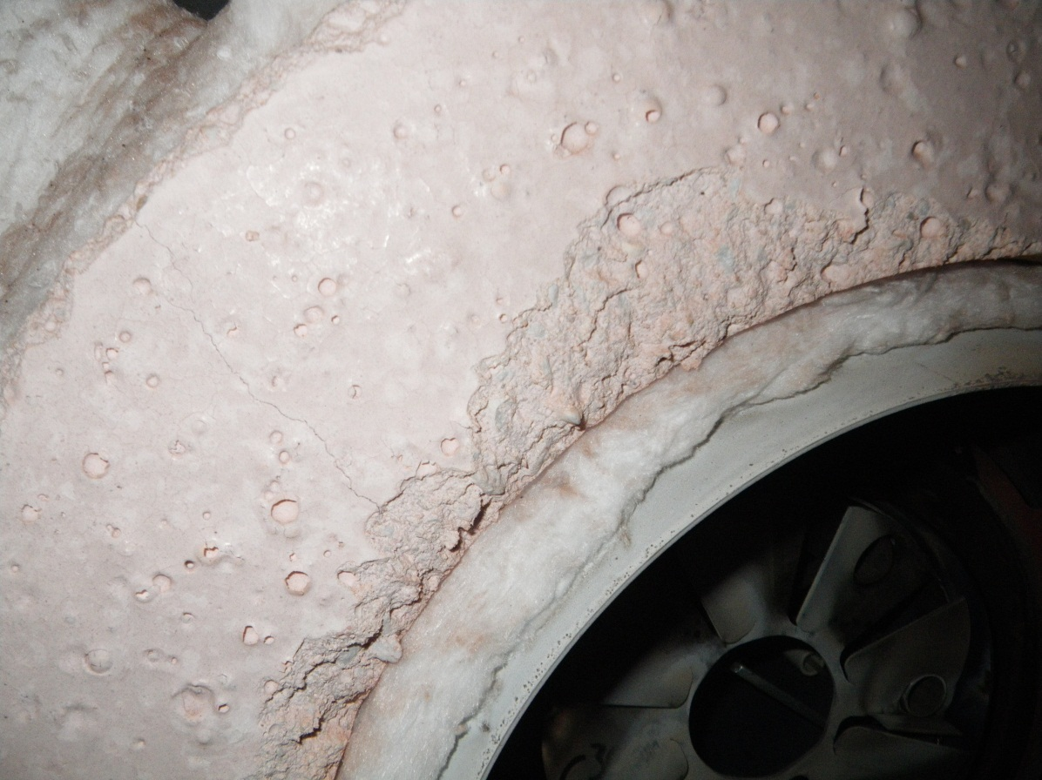:

7) Burner Assembly Overview:
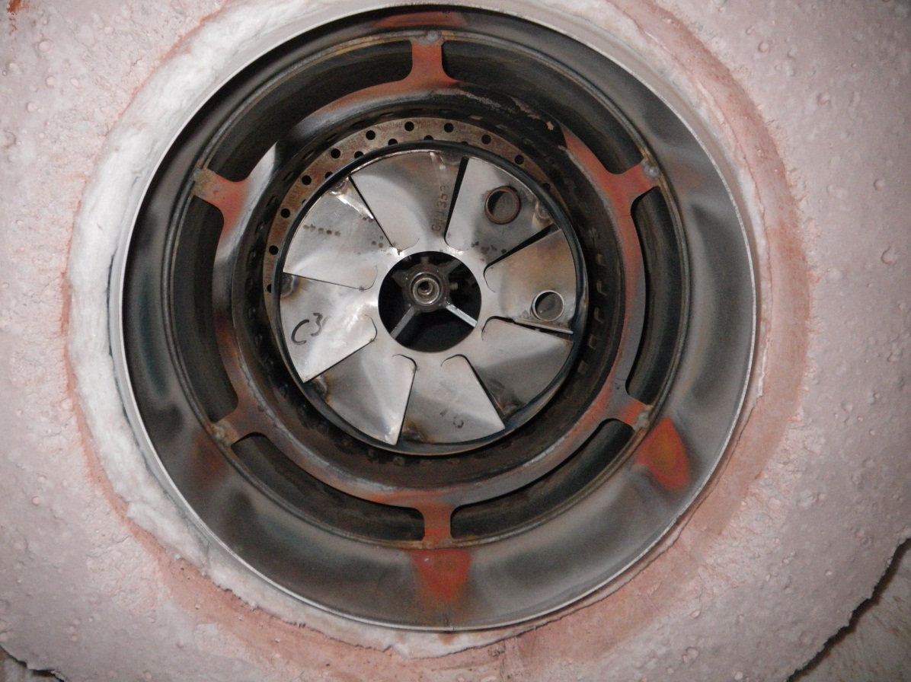

5) Burner End towards Manway Overview:
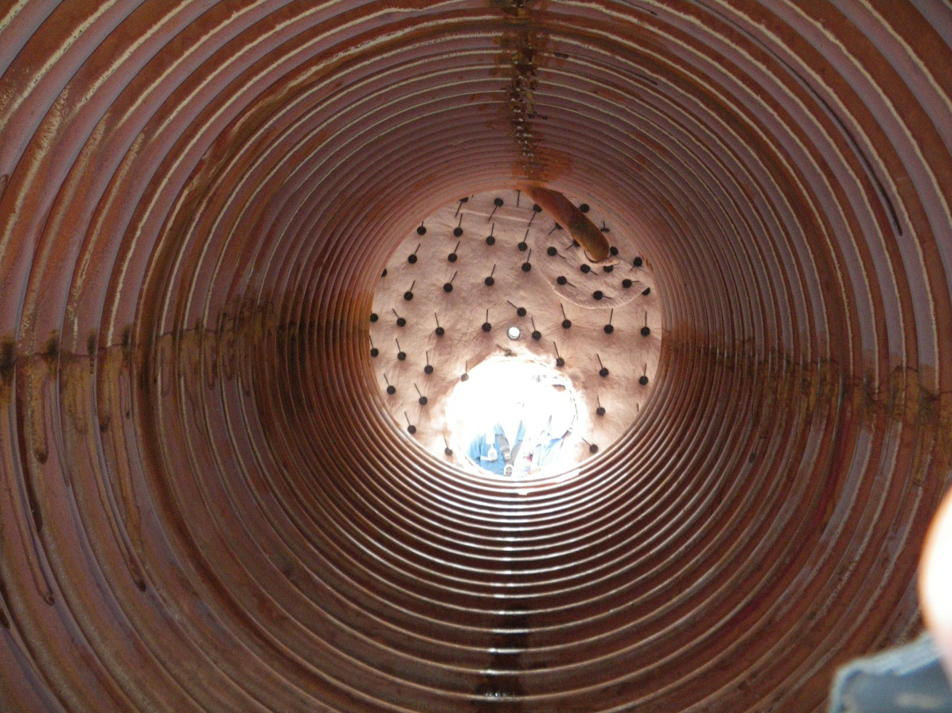

7) Manway Cover:
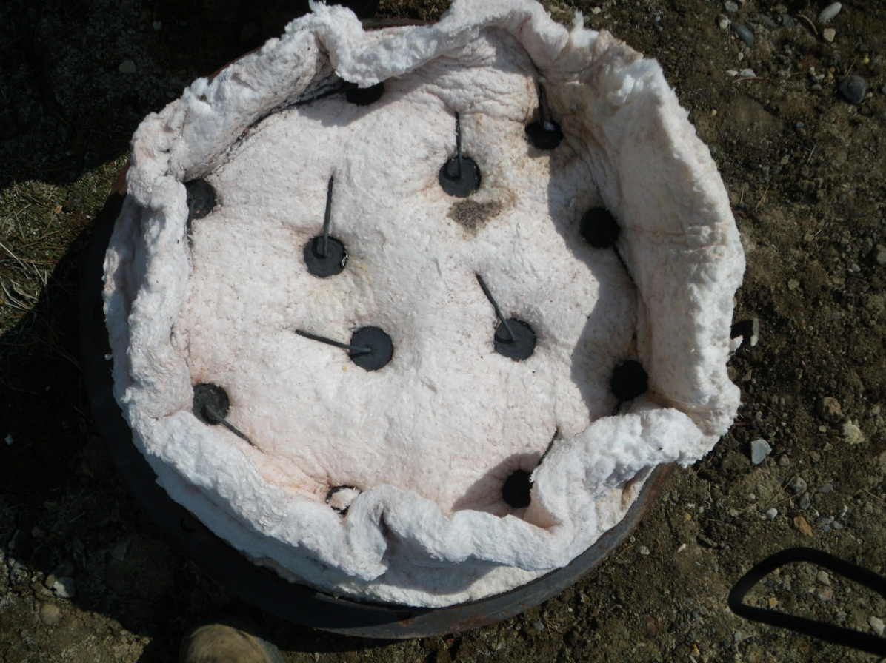

5) Hot Gas Leak:
