Compressor Package S/N 03-204

Cat 3408 TALE Engine S/N BAZ00198

Sullair PDR-24X S/N 006-0300-81998

Cooler – ACE JA6 S/N 03354

Panel – Motiv RCS-205 S/N 2704

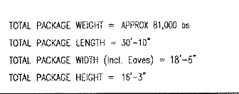

Advantage RV Storage

Box 22, Site 17, RR 2

Strathmore, AB T1P 1K5

403-934-4499