9 pieces - Stairs and Ladder – Note all handrails are 44” high.
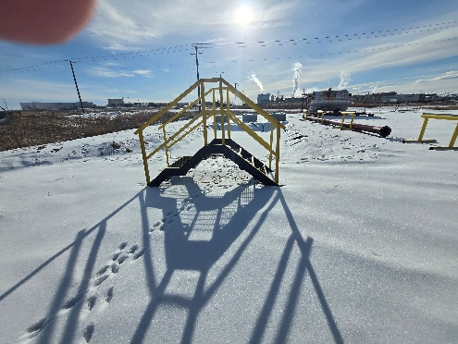Overall length of the stairs is 102” and the gap under the stairs is 34.5”. The stairs are made from 2”X6” I beam. Stairs 24” high. 7’ total inside space.

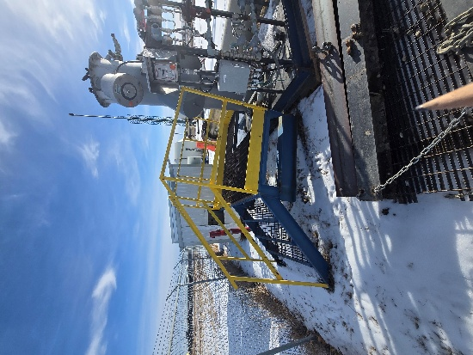This platform was built around a vessel. The stairs are 4’ wide and 4’ high. The platform is 86.5” X 7’6” with a cutout of 5’X42”
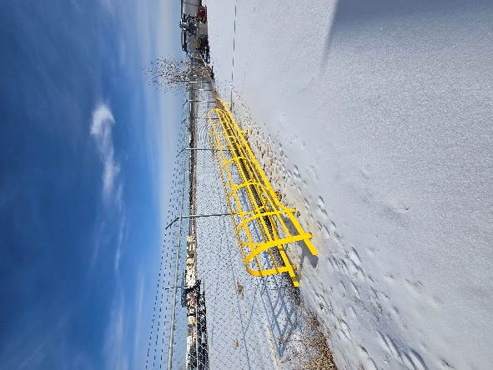The ladder is 24’ long
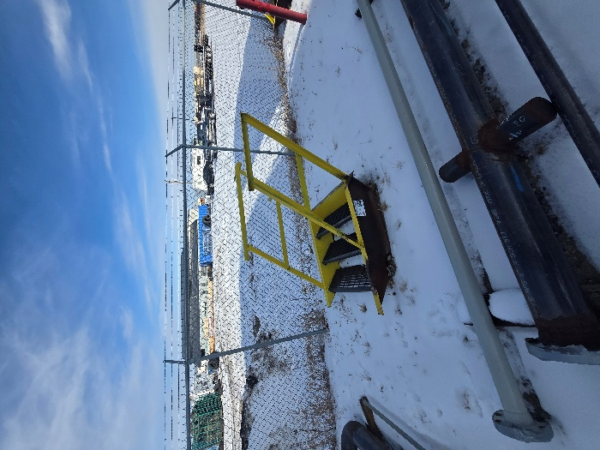There are 4 of these stairs. They are 4’ wide and approx. 4’ high

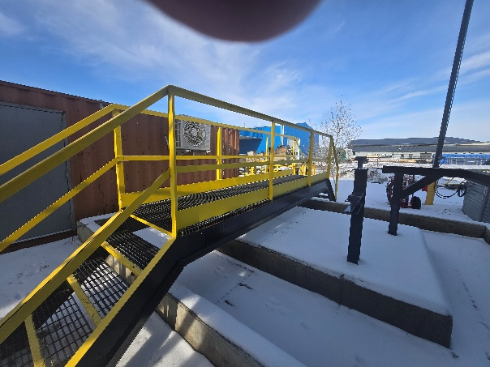This walkway is made from 2.5” X 10” I beam. Standard 3’ wide stairs. The stair climbing up are both 4’ long. Catwalk 14’ 8” span 28” ground to bottom of steel.

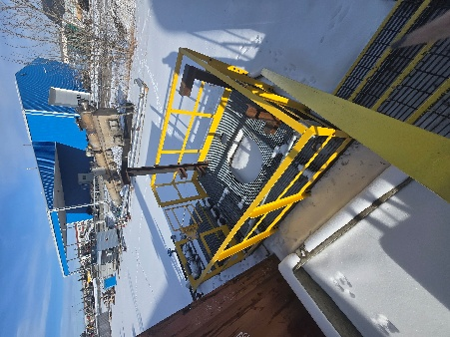 This is 82.5” X 99.5”

